CLEAR SPRING MIDDLE SCHOOL PTSA
NAME: ________________________ PHONE: __________________

STUDENTS NAME: _____________________________________

Contact Information: Amy Babbie – Hendeamy@wcps.k12.md.us
Please Make Checks Payable to Clear Spring PTSA

Please Mark Items That You Wish to Purchase, In Corner Box, Mark Size of Desired Item, Fill in Quantity of Desired Items Under Size Box in Boxes Marked QTY

Ladies Perfect Blend V-Neck Tee – Grey $12.00
 |  | 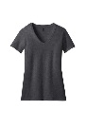
 | YL | S | M | L | XL
QTY
 | 2XL | 3XL | 4XL
QTY

Ladies Perfect Tri Crew Tee $12.00
 |  | 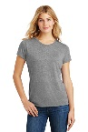
 | YL | S | M | L | XL
QTY
 | 2XL | 3XL | 4XL
QTY

Men’s Perfect Tri – ¾ Sleeve Tee $14.00
 |  | 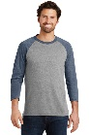
 | YL | S | M | L | XL
QTY
 | 2XL | 3XL | 4XL
QTY

Men’s Perfect Tee $12.00
 | 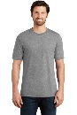
 | YL | S | M | L | XL
QTY
 | 2XL | 3XL | 4XL
QTY

Sport-Tek Fleece Full-Zip Hooded Jacket – Grey $40.00
 |  | 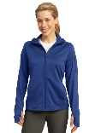
 | YL | S | M | L | XL
QTY
 | 2XL | 3XL | 4XL
QTY

Sport-Tek Fleece Full-Zip Hooded Jacket – Grey $40.00
 |  |  | 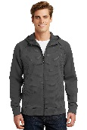
 | YL | S | M | L | XL
QTY
 | 2XL | 3XL | 4XL
QTY

Camo – Beanie Cap – Black/Military/Pink $10.00
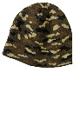
QTY
QTY

Total Order Amount Due __________

Check # __________

Cash Enclosed _______

Ladies Perfect Blend
V-Neck Tee – Grey $12.00
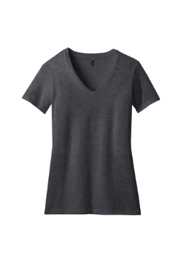
Ladies/Mans Perfect Tri Crew Tee $12.00
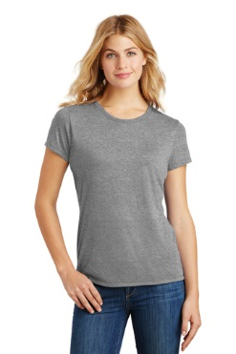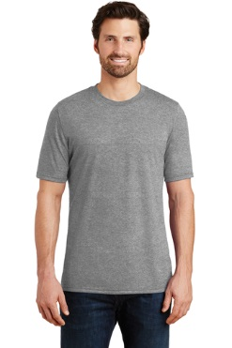

Men’s Perfect Tri – ¾ Sleeve Tee $14.00

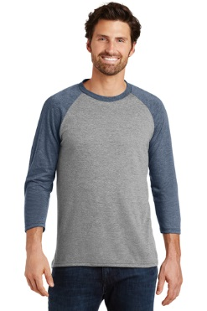

Sport-Tek Fleece Full-Zip Hooded Jacket – Grey $40.00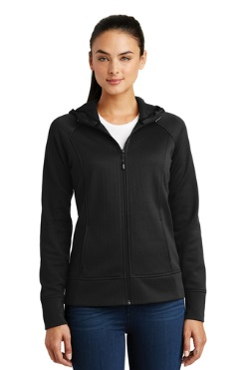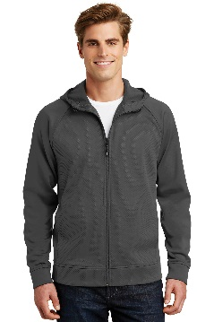

Camo – Beanie Cap – Black/Military/Pink $10.00
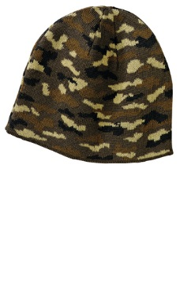
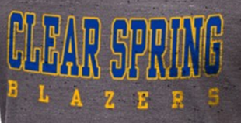
Design for Ladies/Men’s Tee

Design for Jackets

Design for Beanie

